Mechanical Stability and Handling Kinetics of a Natural-Fiber Bio-Geosynthetic Composite from Typha domingensis and Boehmeria nivea under Accelerated Aging

Luiz Diego Vidal Santos
Assistant Professor (PhD), Department of Human Sciences and Philosophy
State University of Feira de Santana, Feira de Santana, Bahia, Brazil
ORCID: https://orcid.org/0000-0002-9747-1276
E-mail: ldvsantos@uefs.br

Francisco Sandro Rodrigues Holanda
Associate Professor (PhD), Department of Agronomic Engineering
Federal University of Sergipe, São Cristóvão, Sergipe, Brazil
ORCID: https://orcid.org/0000-0001-6812-6679
E-mail: fholanda@academico.ufs.br

Emersson Guedes da Silva
Zootechnician, Department of Animal Science
Federal University of Sergipe, São Cristóvão, Sergipe, Brazil
ORCID: https://orcid.org/0009-0004-9742-6215
E-mail: academicoguedes@gmail.com

Alarico José da Silva Azerêdo
Undergraduate Student, Department of Animal Science
Federal University of Sergipe, São Cristóvão, Sergipe, Brazil
ORCID: https://orcid.org/0009-0002-9805-9870
E-mail: alaricoazeredo@academico.ufs.br

José Joatan Rodrigues Júnior
Associate Professor (PhD), Department of Physics
Federal University of Sergipe, São Cristóvão, Sergipe, Brazil
ORCID: https://orcid.org/0000-0001-6473
E-mail: joatan@academico.ufs.br

Renisson Neponuceno de Araújo Filho
Associate Professor (PhD), Department of Rural Technology
Federal Rural University of Pernambuco, Recife, Pernambuco, Brazil
ORCID: https://orcid.org/0000-0002-9747-1276
E-mail: renisson.neponuceno@ufrpe.br

Eliana Midori Sussuchi
Associate Professor (PhD), Department of Chemistry
Federal University of Sergipe, São Cristóvão, Sergipe, Brazil
ORCID: https://orcid.org/0000-0001-9425-0921
E-mail: midori@academico.ufs.br

Alceu Pedrotti
Associate Professor (PhD), Department of Agronomic Engineering
Federal University of Sergipe, São Cristóvão, Sergipe, Brazil
ORCID: https://orcid.org/0000-0003-3086-8399
E-mail: alceupedrotti@gmail.com

Cicero Inácio da Silva Filho
Postdoctoral Researcher, Department of Chemistry
Federal University of Sergipe, São Cristóvão, Sergipe, Brazil
ORCID: https://orcid.org/0000-0003-2486-229X
E-mail: silva.cicero.filho@gmail.com

ABSTRACT
Substituting petroleum-derived geosynthetics with bio-based materials offers promising opportunities for sustainable soil bioengineering. We evaluated the mechanical performance and degradation patterns of a biogeosynthetic composite fabricated from Typha domingensis and Boehmeria nivea lignocellulosic fibers, impregnated with polymeric resin for erosion control applications. Specimens underwent accelerated UV aging (5 h radiation + 1 h condensation per cycle) for 120 cycles (720 h total exposure). Tensile and puncture properties were quantified through standard testing protocols, with statistical analysis performed via Generalized Linear Models (gamma distribution, log link), Generalized Estimating Equations, and Weibull reliability functions. Tensile strength showed no significant temporal variation, whereas strain capacity declined markedly, demonstrating ductility's vulnerability to photodegradation. Puncture resistance remained temporally consistent, with coefficient of variation decreasing to 8.67% at 90 cycles (versus 14.2–36.6% for tensile parameters). Weibull analysis yielded β = 3.40 and η = 19.93 kN/m for tensile failure, and β = 4.46 and η = 1784.19 N for puncture, indicating reduced multiaxial scatter. The 10th percentile puncture strength (P10 = 1077.54 N) and peak values at 30 cycles (2014.91 N) suggest secondary curing or post-resinification effects. Quantile–Quantile plots confirmed statistical adequacy (R² > 0.95). The composite maintained functional performance throughout the critical vegetation establishment period (≈60 cycles), validating its suitability for eco-engineering deployment.

Highlights
- Typha and ramie fibers presented reliable and stable mechanical performance
- Aging reduced fiber´s ductility while tensile stiffness stayed stable.
- Tensile resistance showed remarkable performance with no temporal variation.
- Composite showed remarkable viability for sustainable erosion control.

Keywords: lignocellulosic fibers | geocomposites for erosion control | reliability modeling | Weibull analysis | accelerated UV aging | biopolymer reinforcement | soil bioengineering

1 | Introduction

In the context of global climate change and the increasing frequency of extreme weather events, the development of resilient and effective erosion control solutions has become a scientific and technological priority [1]. The prevailing linear economy paradigm associated with petrochemical-based polymers, which is marked by high embedded energy, carbon emissions, and long-term environmental persistence, introduces a paradox: solving an environmental issue (erosion) by exacerbating others, such as plastic pollution and greenhouse gas accumulation [2, 3].
In response to this contradiction, soil bioengineering has promoted a shift toward renewable and biodegradable material solutions. In this context, natural fiber-reinforced (NFs) biocomposites have emerged as promising materials with superior intrinsic functionalities for geotechnical applications. Composed primarily of cellulose, hemicellulose, and lignin, these fibers offer low density, high strength-to-weight ratios, and inherent biodegradability, which are attributes that align with the principles of circular economy and ecological design [4, 5]. However, transferring this potential from laboratory scale to the field poses a critical challenge: environmental degradation, such as ultraviolet (UV) radiation and moisture cycles, which may induce photo-oxidative degradation and hydrolysis of their polymeric constituents [6].
Overcoming this challenge hinges on interfacial engineering between the typical hydrophilic fibers and hydrophobic polymer matrices. The mechanical performance of geocomposites depends largely on the quality of load transfer across this interface. Chemical incompatibility is the main obstacle to structural optimization. Recent advances in surface modification techniques, such as alkaline treatment, silanization, and acetylation, have reduced free hydroxyl group concentrations and increased surface roughness, leading to improved chemical compatibility and increased mechanical anchorage. These modifications have shown tensile strength and elastic modulus improvements ranging from 25% to 60% [7, 8].
Simultaneously to fiber treatment strategies, the development of renewable polymer matrices, such as biopolyesters and epoxides obtained from vegetable oils, offers additional benefits. These “green” resins can reduce CO₂-equivalent emissions by 35–60% compared to their fossil-derived counterparts while maintaining adequate mechanical performance for geotechnical uses (e.g., elastic modulus: 2.8–4.5 GPa; tensile strength: 45–85 MPa) [9,10].
These systems transcend the passive function of mechanical reinforcement and actively integrate into the ecosystem. Multifunctional structures, designed through strategically layered overlaps, can simultaneously optimize drainage, water retention, slope stabilization, and plant growth promotion [11, 12]. In this context, plant species with both structural and biochemical functionalities are of particular interest. Typha domingensis (cattail), an aquatic macrophyte with global proliferation and high biomass productivity, stands out as an excellent candidate. In addition to its fibers exhibiting mechanical characteristics suitable for reinforcement, its biomass carries an arsenal of bioactive compounds, including polyphenols and polysaccharides, which display allelopathic activity and the potential to modulate the rhizosphere, suppressing weed germination and stimulating beneficial biogeochemical processes [13, 14]. Thus, there is significant value potential in geocomposites that function simultaneously as containment structures and environmental biomodulators, catalyzing ecological succession and soil recovery [15, 16].
Despite this unique multifunctional potential, the technical feasibility of Typha domingensis-based geocomposites remains undetermined due to the lack of robust data on their long-term mechanical resilience. In contrast, studies involving traditional fibers such as sisal (Agave sisalana), curauá (Ananas erectifolius), and flax (Linum usitatissimum) have already characterized their behavior under accelerated aging, revealing performance losses and mechanical variability [17]. The response of Typha to photo-oxidative degradation, however, remains a critical unknown.
The central hypothesis of this study is that geocomposites made with natural fibers from Typha domingensis and Boehmeria nivea maintain stable mechanical performance under accelerated UV aging, presenting a degradation curve compatible with the critical period of vegetation cover establishment in soil bioengineering. To this end, the objective of this study was to characterize the evolution of the mechanical behavior of natural fiber geocomposites made from Typha domingensis and Boehmeria nivea subjected to accelerated UV aging regimes.
Thus, the material is expected to exhibit a mechanical degradation profile aligned with the critical time window for plant establishment in soil bioengineering projects, maintaining sufficient functional integrity even after exposure to accelerated UV radiation. The results obtained in this study aim to fill a crucial knowledge gap by providing the technical and scientific foundation required to validate and enable the safe application of this promising sustainable alternative in real-world erosion control scenarios.

2 | Material and methods

2.1 | Production of Geocomposites

The experiment was conducted at the Soil Erosion and Sedimentation Laboratory (LABES) of the Department of Agricultural Engineering, Sergipe Federal University. Fibers from the species Typha domingensis were obtained by selectively removing the aerial portion of the plant, preserving the rhizomatous system to ensure natural regrowth. To optimize processing, the leaves were segmented into leaf blades and basal sheaths (Figure 1a), followed by mechanical defibration using a guillotine-type cutting machine (Figure 1b). The fibers obtained from the sheath were washed in running water and subjected to passive environmental drying (Figure 1c), resulting in morphological homogenization suitable for integration into the geocomposites (Figures 1d–e).
In parallel, the leaf blades were dehydrated and mechanically comminuted to produce plant particulates (Figure 1f). Both the sheath fibers and the leaf particulates were treated with a natural polyurethane resin derived from castor oil, using D-limonene as a solvent and a natural thixotropic agent (Figure 1g). The two-component formulation was established at a stoichiometric ratio of 2:1 (isocyanate prepolymer:polyol). The functional geocomposite was prepared by integrating the two plant fractions and additives in the following proportions: 24% Typha leaf blade, 20% Typha sheath fibers, 20% plant-based polyurethane resin, 6% D-limonene solvent, and 30% natural thickener. After complete homogenization, the multiphase system was placed in a metal pressing mold with standardized geometry and compacted under a uniaxial load of 1 ton for 24 h in a hydraulic press (Figure 1h), ensuring proper densification.

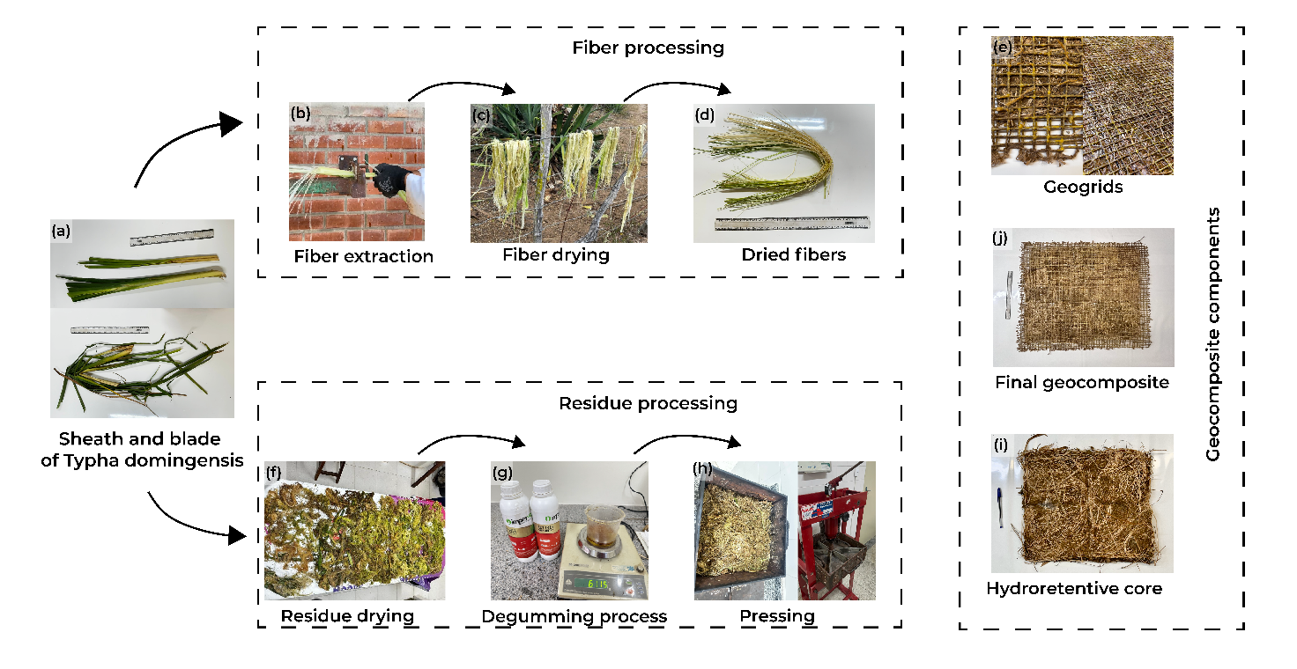
FIGURE 1 | Fiber extraction, chemical treatment, and development of natural geocomposites.

Considering the intrinsic biometric variability of the species, dimensional analyses revealed that the processed fibers used in the vegetal geotextile had diameters ranging from 0.04 to 0.06 mm, while the ramie filaments used in the geogrid exhibited a titration of 0.77 Tex, corresponding to approximately 0.6 mm (Figure 1e). The resulting drainage cores had a nominal thickness of 50 mm and an apparent density of 0.625 g·cm^{–3} (Figure 1i). The integral geocomposite exhibited a stratified profile of 100 mm and a global density of 1.432 g·cm^{–3} (Figure 1j).

2.2 | Geogrid Production

The structural core of the geocomposite, a geogrid, was produced using natural fibers from Typha domingensis (cattail). The manufacturing process began with the harvesting and preparation of fibers. Cattail leaves were separated into leaf blades and sheaths. The sheath fibers were washed in running water and dried in a shaded, ventilated area for six to eight days, until free moisture was eliminated. The geogrid was braided on a wooden mold measuring 1.20 × 1.20 m, equipped with fixed pins spaced at regular intervals of 0.05 m. The dry fibers, previously twisted to an average diameter of approximately 6 mm, were arranged longitudinally and transversely on the mold. At each fiber intersection, a hand-tied knot was applied to ensure structural stability, forming a mesh with 25 mm² openings (Figure 2a). Subsequently, the geogrid underwent waterproofing to enhance durability and resistance to environmental degradation. This consisted of applying two coats of a two-component vegetable resin (castor oil-based) in a 2:1 prepolymer:polyol ratio, using a high-pressure spray compressor. The treated structure was then cured and dried in the shade for 30 days before being integrated into the final geocomposite or subjected to characterization tests. The final laminar geocomposite structure consisted of three functional layers arranged symmetrically. The central core comprised the water-retaining material previously described, with a nominal thickness of 50 mm and density of 0.625 g·cm^{–3}. The layers were arranged in the following sequence: lower geogrid, water-retaining core, and upper geogrid. The resulting geocomposite had a total nominal thickness of 80 mm, a density of 1.432 g·cm^{–3}, and a semi-rigid laminar shape, allowing it to be rolled for transportation and field installation (Figure 2b).

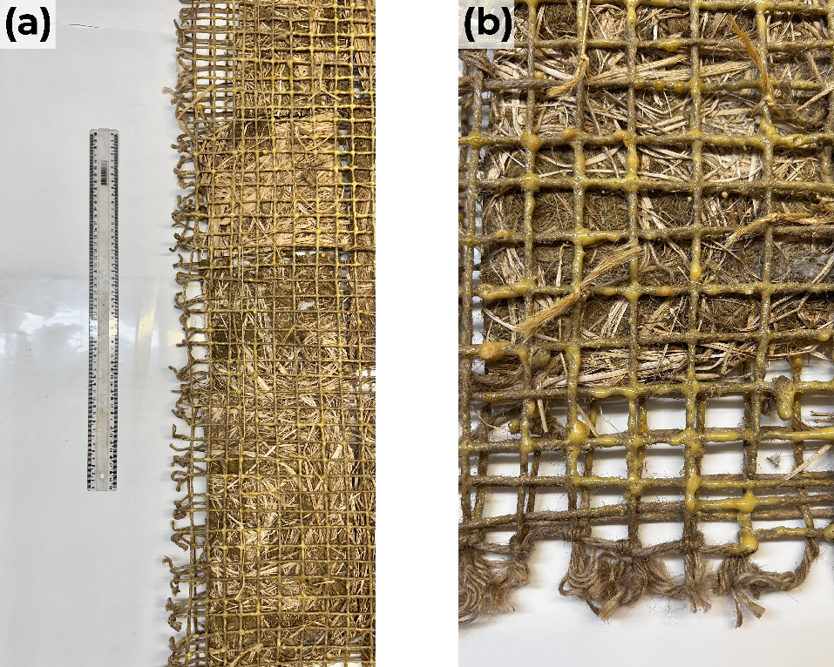
FIGURE 2 | (a) Laminar geocomposite mesh developed from natural fibers. (b) Complete geocomposite structure highlighting the multilayer configuration: two Typha domingensis geogrids (upper and lower) and the central water-retaining core.
2.3 | Accelerated Photo-Oxidative Degradation

The resistance of the geocomposite to ultraviolet radiation-induced degradation was evaluated through accelerated exposure in a UV chamber built according to the principles of EN 12224:2001, with structural adaptations to better simulate environmental conditions comparable to natural solar radiation. The chamber was equipped with combined UV-A (315–400 nm), UV-B (280–315 nm), and visible (450–700 nm) fluorescent lamps, providing a composite emission spectrum that mimicked global solar radiation. The average irradiance values were 6,214.70 W·m^{–2} for UV-A, 2,281.72 W·m^{–2} for UV-B, and 937,437.00 W·m^{–2} in the visible range. According to the spectrometric data, the combined spectral curve (UV + VIS) consistently reproduced the spectral distribution of incident sunlight, with clear emission peaks between 360–380 nm (UV-A) and 280–315 nm (UV-B), along with continuous coverage across the visible range up to approximately 750 nm (Figure 3).

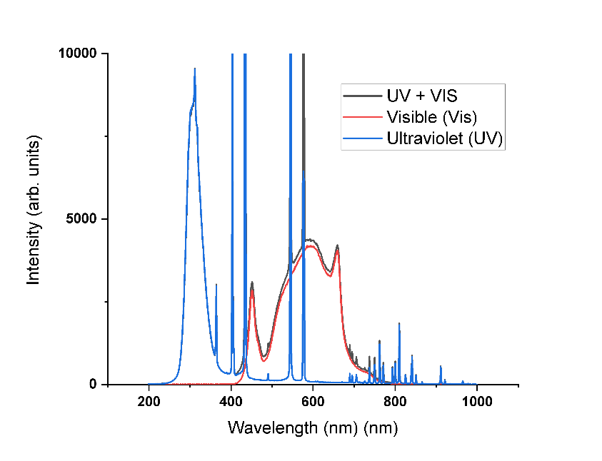
FIGURE 3 | Emission spectrum of the UV chamber lamps, with irradiance distribution in the UV-B (280–315 nm), UV-A (315–400 nm), and visible (450–700 nm) bands. The black curve represents the combined emission (UV + VIS); the blue and red curves correspond to the isolated ultraviolet and visible components, respectively.

The lamps were selected based on their spectral emission capacity with photo-oxidation mechanisms in lignocellulosic polymers, particularly in energy ranges sufficient to break C–C and C–H bonds (Figure 4a). The simultaneous presence of UV-B and UV-A radiation promotes polymer chain degradation through direct excitation and free radical generation, while the visible component contributes to material heating and accelerates thermally activated oxidation and hydrolysis. The UV exposure chamber was constructed with programmable timers, dedicated circuit breakers for system safety, water containment trays, and thermal sensors (Figure 4b). Temperature control was performed with a black panel thermometer, maintaining an average internal temperature of approximately 40 °C, with fluctuations of ±3 °C. Relative humidity was kept near 60%, reproducing conditions that synergistically activate degradation mechanisms by both moisture and radiation.

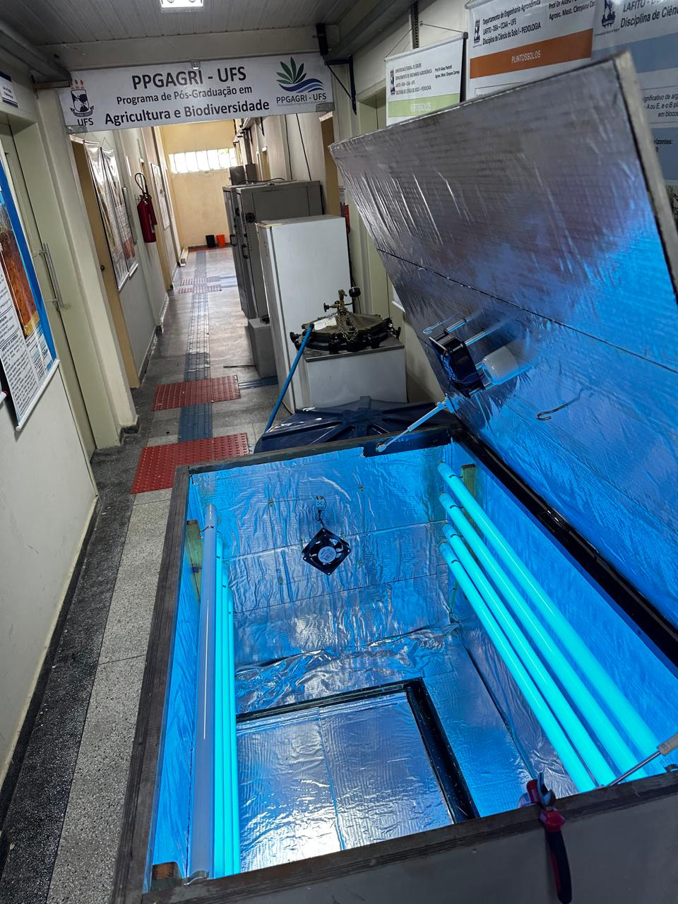 | 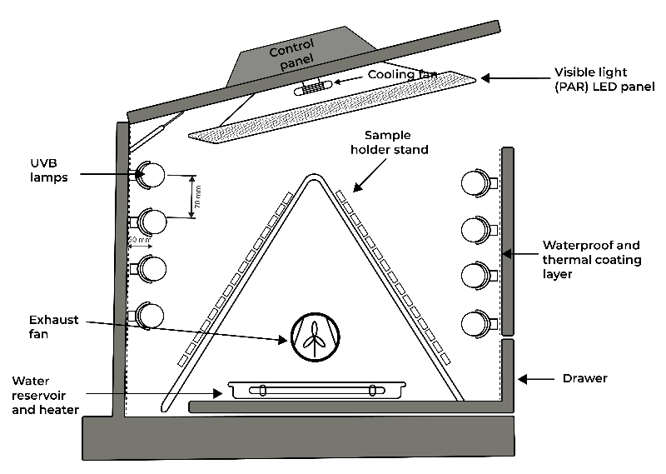
FIGURE 4 | (a) Internal view of the UV chamber used in the photo-oxidative degradation tests, showing the symmetrical arrangement of UV lamps and the lower humidification tray. (b) Schematic of the chamber’s main components, including temperature control elements, timers, radiation sources, and heating compartments.

The degradation test was performed in repeated 6-hour cycles subdivided into three sequential stages: (i) immersion in water for 15 min (replacing the spray system recommended by the standard), followed by free drainage of residual water; (ii) heating in an oven at 105 °C for 1 h to intensify thermal oxidation and hydrolysis; and (iii) continuous exposure for 4 h 45 min in the UV chamber under controlled radiation. Four cycles were run per day. Samples were mounted on stainless steel mesh supports with openings ranging from 15 to 20 mm and wire diameters of approximately 1 mm, providing an effective exposure area between 87% and 90% without mechanical loading. This setup ensured homogeneity in radiation incidence and thermal dissipation. Control samples were stored in a dark, dry environment throughout the experiment for comparison with the post-exposure mechanical properties. The exposure protocol followed seven experimental periods (cycles 1 to 180), ranging from 0 to 180 days, with periodic sample replacement performed at the end of each period.

2.4 | Mechanical Characterization of Fibers

The mechanical characterization of the geocomposites was performed at the Materials Engineering Laboratory of the Sergipe Federal University using an EMIC DL universal testing machine (300 kN), calibrated according to ISO 7500-1:2018 (Figure 4). Before mechanical testing, the specimens were subjected to accelerated degradation in a climate-controlled chamber, under controlled conditions combining thermal cycling (20–60 °C / 12 h) and UV-B radiation (280–320 nm; 0.68 W·m^{–2} for 8 h·day^{–1}), totaling 5.44 W·h· m^{–2} per cycle. This protocol aimed to simulate representative environmental stressors and accelerate photodegradation processes while maintaining correlation with natural light conditions. A cumulative total of 600 h of UV exposure was applied over 120 daily cycles.
Tensile tests were conducted on the EMIC DL 30000 machine, following NBR ISO 10319:2013 with adaptations from ASTM D4595. Samples had a useful width of 200 mm and were tested with a 100 mm grip separation and a constant deformation rate of 20 mm·min^{–1}, under controlled temperature (23 ± 2 °C) and relative humidity (50 ± 5%). For each exposure condition and treatment, seven independent specimens (n = 7) were tested, totaling 105 replicates. Steel grips with grooved faces ensured stable and uniform clamping, preventing slippage or localized stress concentrations. During testing, load-deformation (Load × Displacement) curves were recorded at 100 Hz, allowing the calculation of maximum tensile stress (σ_{max} = F_{max}/ A₀), strain at failure (ε_{max}= ΔL / L₀), and secant stiffness (J_{sec}), determined in the elastic interval between 0.1% and 0.3% strain, according to Bourmaud et al. [2].
Static puncture tests were performed according to NBR ISO 12236:2013, adapted to the Mini-CBR configuration. Circular specimens (70 mm Ø) were clamped between metal rings with an internal opening of 50 mm, and a hardened steel piston (17 mm Ø; 58–60 HRC) was applied perpendicular to the specimen surface. Penetration was performed at a rate of 50 mm·min^{–1} until complete rupture, operationally defined as a reduction greater than 95% of the maximum registered load.

2.5 | Statistical Analysis

The data obtained from tensile and puncture tests on the geocomposites were analyzed using Generalized Linear Models (GLMs), employing a gamma distribution with a logarithmic link function, suitable for the continuous, positive, and asymmetric nature of the strength variables. The experimental design was completely randomized in a 2 × 12 factorial arrangement, with two treatments (with and without waterproofing resin) and twelve exposure cycles, totaling 120 experimental units and 600 h of UV-induced degradation.
The dependent variables included maximum tensile stress (σ_{max}) strain at rupture (ε_{max}), and secant stiffness (J_{sec}), determined according to NBR ISO 10319:2013 and NBR ISO 12236:2013. Model adequacy was assessed via the Shapiro–Wilk and Levene tests. The gamma distribution was selected based on the lowest values of the Akaike (AIC) and Bayesian (BIC) information criteria and by Deviance/df and Pearson/df ratios below 1, indicating the absence of overdispersion.
The temporal progression of mechanical degradation was evaluated using repeated-measures ANOVA, with exposure time as a within-subject factor and surface treatment as a between-subject factor. Temporal dependence between measurements was additionally modelled using Generalized Estimating Equations (GEE) with a first-order autoregressive matrix (AR-1), selected based on the Quasi-likelihood Information Criterion (QIC). Robust standard errors were calculated using the Huber–White correction, and coefficient significance was tested using the Wald χ² test. Multiple comparisons between marginal means were adjusted via the Bonferroni correction (α = 0.05). Degradation kinetics were modelled using second-order and logarithmic fits, with the most parsimonious model selected based on AIC and R².
The shape (β) and scale (η) parameters were estimated for each experimental group. Goodness-of-fit was assessed via the Anderson–Darling (AD) and Kolmogorov–Smirnov (KS) tests. Survival functions, hazard rates, and critical rupture percentiles (P₁₀, P₅₀, and P₉₀) were obtained. Weibull parameters were compared between treatments and exposure times using GLMs with gamma distribution, followed by Type II deviance analysis (ANOVA) and Tukey’s multiple comparison test (α = 0.05). For correlated measures, the GEE model with AR-1 structure was applied.

2.6 | Mechanical Reliability Analysis

The reliability analysis of tensile and puncture tests was performed using the Weibull distribution, following the methodology proposed by Atoui et al. [18]. Two- and three-parameter Weibull distributions (2P and 3P) were fitted using both Maximum Likelihood (ML) and Least Squares (LS) methods, with probability estimators based on Kaplan–Meier, Hazen, and Benard probability estimators. The Weibull distribution is defined by the following equations:
$$f(t)=\frac{β}{η}{\left(\frac{t}{η}\right)}^{β-1}e^{-(t/η)^{β}}$$ | (1)
$$F(t)=1-e^{-(t/η)^{β}}$$ | (2)
$$R(t)=e^{-(t/η)^{β}}$$ | (3)
$$h(t)=\frac{f(t)}{R(t)}=\frac{β}{η}{\left(\frac{t}{η}\right)}^{β-1}$$ | (4)

where β is the shape parameter (associated with the failure regime), and η is the scale parameter, corresponding to the material’s characteristic life.
The survival function R(t), hazard function h(t), and critical rupture percentiles (P₁₀, P₅₀, and P₉₀) were estimated for each experimental condition. Goodness of fit was assessed using the Anderson–Darling (AD) and Kolmogorov–Smirnov (KS) tests. All analyses were performed in the R environment (version 4.5.1; R Core Team, 2024), using the following packages: car, geepack, WeibullR, fitdistrplus, survival, goftest, emmeans, boot, ggplot2, effectsize, and dplyr.

3 | Results and Discussion

3.1 | Mechanical Reliability Analysis

The reliability analysis, based on the Weibull distribution with Maximum Likelihood (ML) parameter estimation, demonstrated that the shape parameter (β) was greater than 1 for both tensile strength (β = 3.403) and rupture strain (β = 2.640), indicating an increasing failure rate over time, which is a typical pattern for materials subjected to progressive degradation. The reliability functions R(t) (Figure 5) illustrate the temporal decrease in survival probability for both mechanical properties, confirming that failure occurs cumulatively rather than randomly. This behavior is consistent with previous studies on the degradation of lignocellulosic composites under accelerated aging, where UV radiation, moisture, and thermal variation promote polymer chain scission, matrix oxidation, and loss of mechanical properties [19, 20].

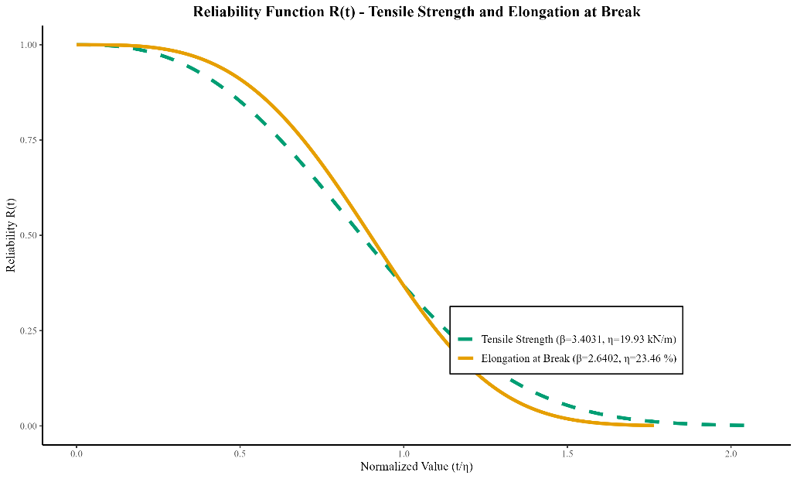
FIGURE 5 | Survival functions R(t) for tensile strength (β = 3.403, η = 19.93 kN·m^{–1}, solid orange) and rupture strain (β = 2.640, η = 23.46%, dashed green) in Typha domingensis-based geocomposites under accelerated degradation, plotted as a function of normalized exposure time (t/η).

For tensile strength, the Weibull parameters were β = 3.403 and η = 19.93 kN·m^{–1}. The β > 1 value indicates that the probability of failure increases over time, characterizing a cumulative damage process typical of materials subjected to progressive degradation. Figure 6 presents the corresponding hazard rate curves h(t) for both properties, confirming this progressive degradation trend and evidencing the non-random nature of failure mechanisms. The scale parameter η, which corresponds to the characteristic life (i.e., the stress level at which ~63.2% of samples fail), was 19.93 kN·m⁻¹. The mean life (μ) was 17.90 kN·m^{–1}, and the median (m) was 17.89 kN·m^{–1}. Under conservative criteria, 10% of samples failed at ≤10.29 kN·m^{–1}, while 90% failed by 25.46 kN·m^{–1}.

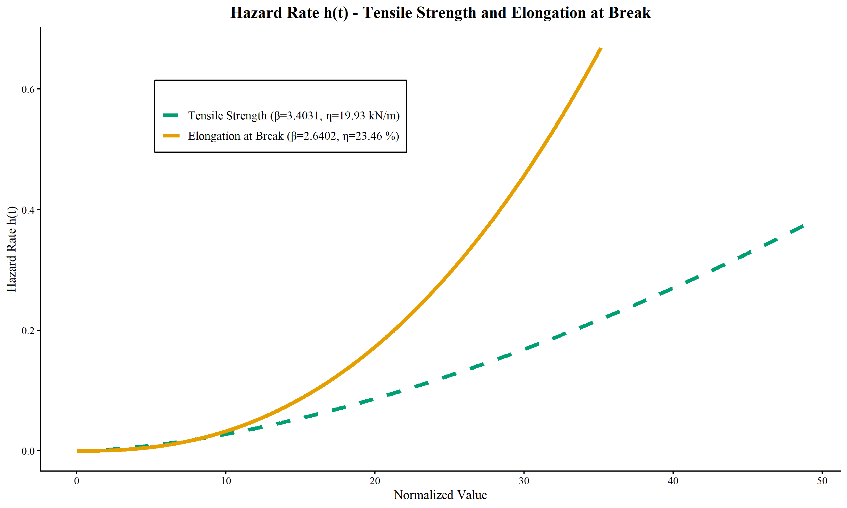
FIGURE 6 | Hazard rate h(t) curves derived from Weibull analysis for tensile strength (β = 3.403, η = 19.93 kN·m^{–1}, μ = 17.90 kN·m^{–1}) and rupture strain (β = 2.640, η = 23.46%, μ = 20.85%) in Typha domingensis-based geocomposites, confirming progressive degradation behavior across exposure time.

In contrast to the relative stability of tensile strength, rupture strain showed greater sensitivity to degradation, with β = 2.640 and η = 23.46%. The lower β value suggests a more gradual but sustained loss of deformability. The mean life μ was 20.85%, and the median was 20.42%. Ten percent of the specimens failed by 10.01% strain, while 90% failed by 32.18%. The Weibull model showed good fit (R² > 0.95), and parameter consistency among replicates confirms result reliability. The difference between the scale parameters (η =19.93 kN·m^{–1} for tensile strength and η = 23.46% for rupture strain) confirms that tensile resistance is more stable than deformability under environmental degradation [21, 22]. This degradation in deformability can be attributed to the loss of fiber flexibility and the stiffness imposed by the resin layer, which, although increasing resistance, restricts internal stress redistribution, favoring localized failure and reducing ductility [23].
Temporal degradation modelling showed a better fit to a linear model, with an estimated time to failure of 13 cycles, reinforcing that strength reduction follows a predictable and continuous pattern. This linearity is advantageous for maintenance planning and field service life prediction, allowing performance loss to be anticipated in a controlled manner [24]. This behavior is likely due to the stabilizing effect of the resin, which acts as a barrier to radiation and moisture penetration, delaying microcrack propagation and maintaining structural integrity [25].
These results are consistent with recent findings in treated lignocellulosic composites, where polymer crosslinking and improved interfacial adhesion contribute to reducing failure rates and preserving stiffness during aging [26]. The inverse relationship between stiffness and ductility observed here is typical of such systems, where enhanced structural strength often comes at the expense of functional flexibility. From an applied perspective, the observed linear behavior in tensile performance and the predictable degradation of strain capacity indicate that the resin-treated geocomposites maintain functional performance within the typical time window required in soil bioengineering, generally limited to the first six months of exposure. The coincidence between the characteristic life of the materials (η) and the critical period for vegetation cover establishment further supports their suitability for erosion control and surface stabilization [27, 28].
The goodness-of-fit of the Weibull model was confirmed by the high correlation coefficients (R² > 0.95) and the consistency of parameter estimates across replicates. The difference in scale values (η = 19.93 kN·m^{–1} for tensile strength vs. 23.46% for rupture strain) reinforces that tensile strength remains more stable than deformability under degradation. This reduction in ductility is attributable to the loss of fiber flexibility and the rigidity introduced by the resin, which, while increasing overall strength, reduces ductility.
These findings suggest that although maximum stress exhibits progressive wear, its degradation follows a more predictable and linear trajectory than strain, which is advantageous for maintenance planning and service life forecasting [29]. This linear trend can be attributed to the resin’s ability to stabilize the fiber structure, slowing the propagation of microcracks and maintaining a more consistent degradation rate [2].

3.2 | Temporal Analysis, Variability, and the Relationship With Plant Material and Treatments

The analysis of maximum tensile strength over 120 exposure cycles revealed non-monotonic behavior, with alternating periods of strength decline and partial recovery (Figure 7). This pattern suggests complex degradation–stabilization dynamics, possibly linked to post-curing of the resin and rearrangement of the fiber–resin interface during aging [30]. Despite the observed fluctuation, the GLM model (Gamma distribution, log link) indicated no statistically significant differences between exposure times (χ²(11) = 1.12; p = 0.148), suggesting that temporal variation, although present in magnitude, did not reach statistical significance at the α = 0.05 level.

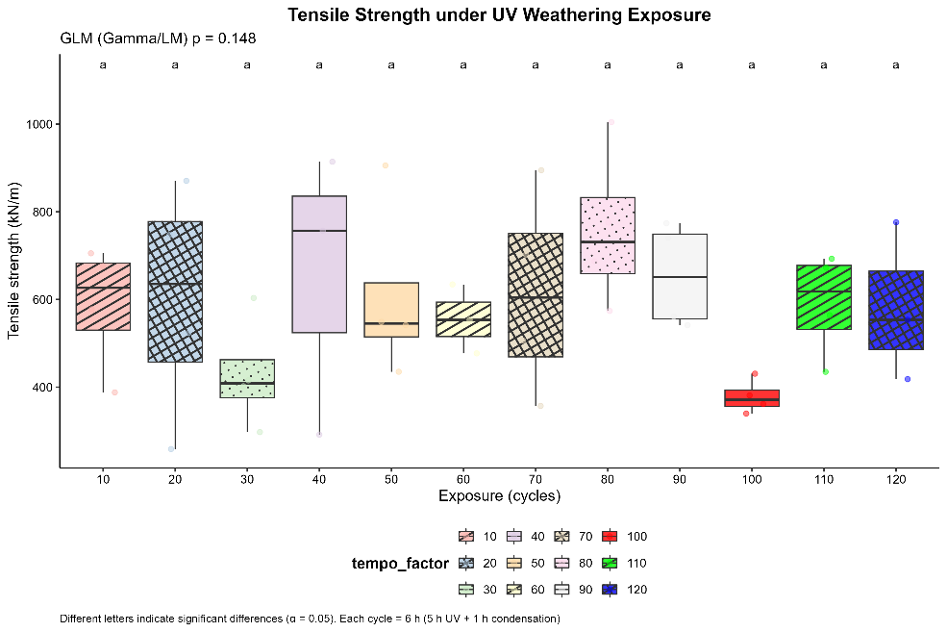
FIGURE 7 | Temporal evolution of tensile strength in Typha domingensis geocomposites under forced photochemical degradation, showing non-monotonic variation likely due to complex interactions between degradation processes and resin stabilization. Equal letters denote no statistically significant differences between exposure times (Tukey’s post-hoc test, α = 0.05).

In contrast, the rupture strain exhibited statistically significant differences over the exposure period (GLM, Gamma–log link: χ²(11) = 24.8; p < 0.001), as illustrated in Figure 8, evidencing that deformation capacity is substantially more sensitive to photochemical degradation than tensile strength.
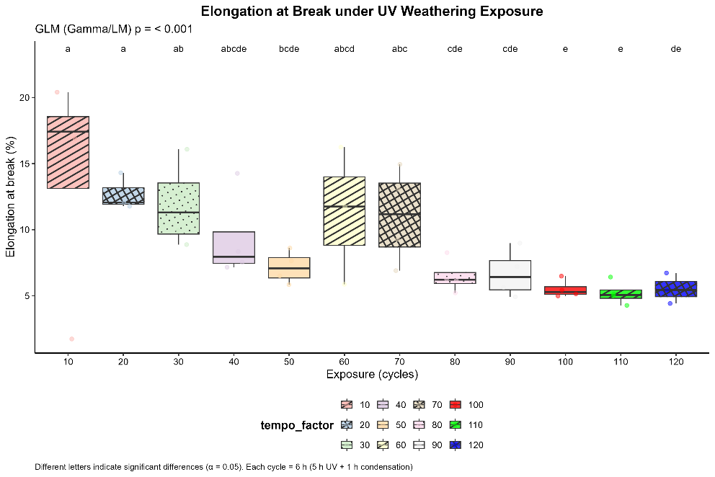
FIGURE 8 | Temporal evolution of rupture strain in Typha domingensis geocomposites under forced photochemical degradation, with different letters indicating statistically significant differences between exposure times (Tukey’s post-hoc test, α = 0.05).
The progressive reduction in strain reflects a loss of ductility and fiber flexibility, attributable to the degradation of the lignocellulosic matrix and increased rigidity induced by the resin, confirming the hypothesis that surface treatment, while protecting mechanical strength, compromises the material’s plastic deformation capacity [31].
Young’s modulus, which represents the initial elastic stiffness of the material, did not show statistically significant differences over the exposure time (GLM, Gamma–log link: χ²(11) = 3.560; p = 0.168), indicating that geocomposite stiffness remained stable during accelerated aging (Figure 9). This stability is consistent with prior results for lignocellulosic composites treated with plant-based resins, in which polymeric crosslinking and effective interfacial adhesion minimize microcrack propagation and maintain structural integrity under UV exposure [32]. Similar studies also highlight that surface hardening and reduced moisture diffusivity due to the resin contribute to preserving the elastic response over time [2]. Therefore, the absence of significant variation in Young’s modulus reinforces the stabilizing role of the polymer matrix in maintaining rigidity and the fiber–resin architecture under prolonged photochemical degradation.

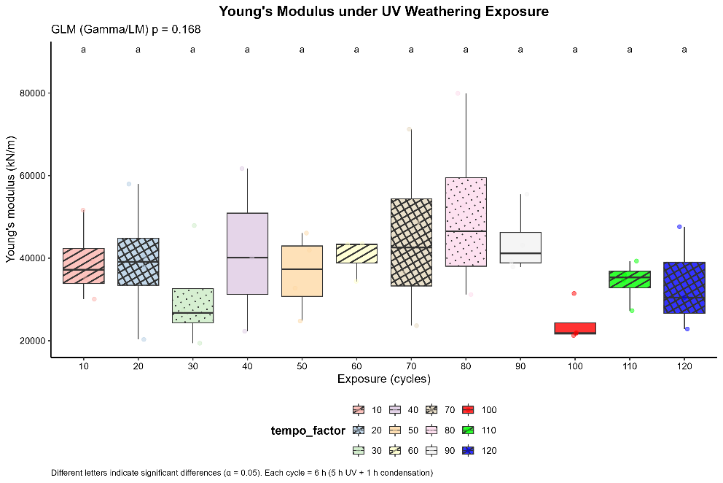
FIGURE 9 | Temporal evolution and distribution of Young’s modulus (kN·m) in Typha domingensis geocomposites under forced photochemical degradation across exposure time (0 to 120 cycles).

Statistical analysis revealed no significant differences between time groups (GLM, Gamma–log link: p = 0.168), with identical letters confirming the absence of significant variation. The stability of elastic stiffness over time suggests that the resin maintains the composite’s mechanical structure, preserving its initial load-responsiveness even under prolonged photochemical degradation, representing a functional advantage for long-term applications in soil bioengineering. Although the second-order polynomial model best fitted the temporal degradation data for maximum stress (R² = 0.108), the low percentage of explained variance (10.8%) and lack of statistical significance (F(2,23) = 1.396, p = 0.268) suggest that degradation does not follow a simple linear pattern and that other non-temporal factors may significantly influence material strength [36].
Bootstrap estimates for maximum stress by exposure time revealed an average of 588.80 N at 10 cycles (95% CI: 506.32–662.31 N), 592.48 N at 20 cycles (95% CI: 431.02–725.92 N), a marked drop to 429.53 N at 30 cycles (95% CI: 339.09–552.94 N), followed by recovery to 554.87 N at 60 cycles (95% CI: 476.95–634.21 N), and a peak of 654.21 N at 90 cycles (95% CI: 546.18–757.29 N). This fluctuation, marked by a dip at 30 cycles and subsequent recovery, may reflect a “self-healing” or adaptive response of the composite, or the influence of complex degradation-stabilization mechanisms that warrant deeper investigation [34]. Such non-monotonic behavior may be explained by the complex interaction between fiber degradation of natural fibers (particularly in Typha domingensis) and the action of the applied resin. Initially, photodegradation tends to affect the amorphous regions of the fibers, leading to mechanical weakening [35]. However, the resin can act as a protective barrier, delaying degradation of crystalline zones and promoting a certain level of stabilization and surface hardening, which may explain the observed recovery in strength at intermediate stages [36]. The specific morphology of each plant fiber, with its different proportions of cellulose, hemicellulose, and lignin content, and considering the way the resin interacts with these structural components, is critical to understanding these dynamics [37]. For instance, lignin-rich fibers may initially resist degradation more effectively, while the resin may enhance load transfer between fibers, compensating for early losses in mechanical cohesion [38].
Intragroup variability (CV) also revealed temporal heterogeneity. The lowest CV was observed at 60 cycles (14.2%), whereas the highest occurred at 20 cycles (36.6%). Despite this variability, Bartlett’s test confirmed homogeneity of variances across exposure times (K² = 3.742, df = 4, p = 0.442), validating the use of parametric tests such as GEE. However, ANOVA revealed no significant effect of exposure time on maximum stress (F(4,21) = 1.222, p = 0.331), reinforcing the complex degradation behavior and highlighting the need for more robust models or refined experimental designs [39]. The observed variability may stem from the intrinsic heterogeneity of natural fibers and how degradation individually affects each fiber within the composite structure [40].
The results obtained for Typha fiber geocomposites align with other studies exploring fiber degradation and the influence of resin coatings. Holanda et al. [41] investigated the climatic resistance of Typha domingensis geotextiles, reporting a 13.86% reduction in tensile strength every 30 cycles for untreated fibers. Application of a double-layer resin decreased this rate to 11%, demonstrating the resin’s protective role in preserving structural integrity and limiting fiber fragmentation [42]. In this context, while the double-layer resin initially provided superior protection, its effectiveness declined in later stages of exposure (after 90 cycles, equivalent to approximately 5–6 months in the field). In contrast, untreated fibers failed before 60 cycles.
This behavior may result from the formation of a rigid barrier that, although initially enhancing strength, retains internal moisture and facilitates the development of microcracks, ultimately accelerating degradation during long-term aging [43]. Such a pattern has also been reported in field studies on natural geotextiles, where initial strength gains due to resin treatment are eventually followed by failure from stress accumulation and hygroscopic saturation [44]. The post-30-cycle recovery in tensile strength, followed by renewed degradation, reflects the complex interaction between fiber degradation and resin protection, an effect consistent with the trade-offs described by Holanda et al. [45]. Despite the resin treatment, the inherent hydrophilicity of natural fibers can lead to moisture uptake. This moisture, coupled with the rigidity imposed by the resin, may induce internal stresses and contribute to localized failures, accelerating degradation at critical exposure intervals.

3.3 | Puncture Tests

The reliability analysis of the puncture tests, fitted to a Weibull distribution with maximum likelihood estimation (Figure 10), revealed a distinct statistical behavior compared to tensile tests. The high β values (>5) obtained for both force and displacement indicate a deterministic failure regime, characterized by low statistical dispersion and high predictability, typical of systems in which failure is governed by internal energy dissipation mechanisms rather than by random material heterogeneities [46]. For the puncture force, the parameters were β = 5.462 and η = 1.784 N. The elevated β confirms the uniformity of failure, while the scale parameter (η) reflects a resistance level higher than that observed under tensile loading. The mean life (μ = 1.627 N) and the median (m = 1.643 N) demonstrate consistency in the distribution, and the percentiles P₁₀ = 1.077 N and P₉₀ = 2.150 N define a safe and wide operational range.

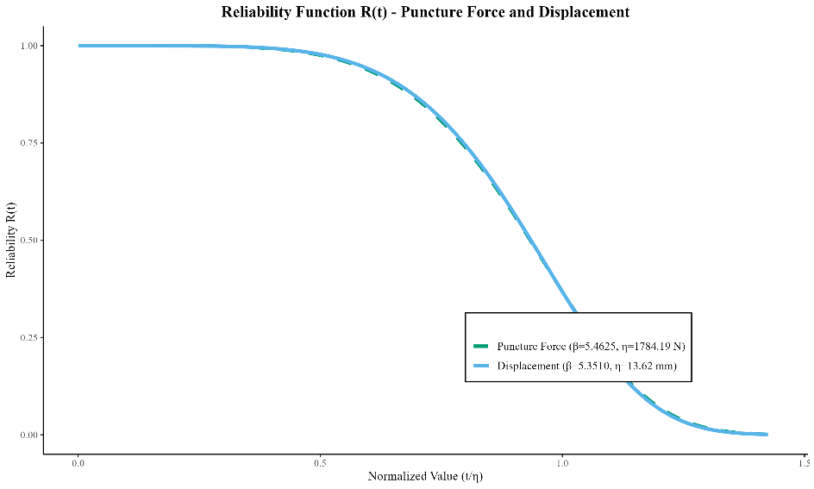
FIGURE 10 | Weibull reliability functions R(t) for puncture force (β = 5.462, η = 1784.19 N, μ = 1627.42 N) and displacement (β = 5.351, η = 13.618 mm, μ = 12.55 mm) in Typha domingensis geocomposites.

For the puncture displacement, the Weibull parameters were β = 5.351 and η = 13.618 mm, with a mean life (μ) of 12.55 mm and a median (m) of 12.72 mm, indicating an approximately symmetrical distribution and a narrow failure amplitude (P₁₀ = 8.94 mm; P₉₀ = 15.91 mm). The higher β value, in contrast to tensile deformation (β = 2.640), confirms that multiaxial deformation behavior is more predictable and with lower variance, reflecting high repeatability across specimens and a deterministic nature of deformability.
Quantile analysis and goodness-of-fit tests confirmed R² > 0.97 for both force and displacement, validating the statistical robustness of the Weibull model. The reliability function R(t) exhibited a controlled and continuous decline, without abrupt transitions, reinforcing the model’s suitability for lifespan prediction in bioengineering applications [47]. The best fit for the temporal degradation model was a modified exponential function, suggesting an initial increase in strength, possibly associated with secondary curing of the resin, followed by stabilization after approximately 60 days. This pattern contrasts with the non-monotonic and partially reversible behavior (recovery) observed in tensile tests, indicating that puncture testing more realistically reproduces performance under complex, multiaxial loading conditions [48, 49]. The difference between the scale parameters (η) of puncture and tensile strength (1.784 N vs. 19.930 kN·m^{–1}) supports the conclusion that puncture strength is intrinsically higher and more stable under degradation. This corroborates the hypothesis that multiaxial loading more effectively engages the three-dimensional structure of the treated fibers, reducing stress concentration and enhancing the internal cohesion of the fiber–resin matrix [54, 55].

3.4 | Temporal Degradation and Structural Stability in Puncture Tests

The puncture force, evaluated across 0 to 120 exposure cycles, did not exhibit statistically significant variation over time (GLM, Gamma – log link: LR χ²(10) = 15.8; p = 0.072), although a marginal variation trend was noted. This result suggests that temporal effects on puncture strength are considerably less pronounced than those observed for tensile rupture strain (Figure 11), reinforcing that multiaxial loading promotes greater mechanical stability and lower sensitivity to photochemical degradation.

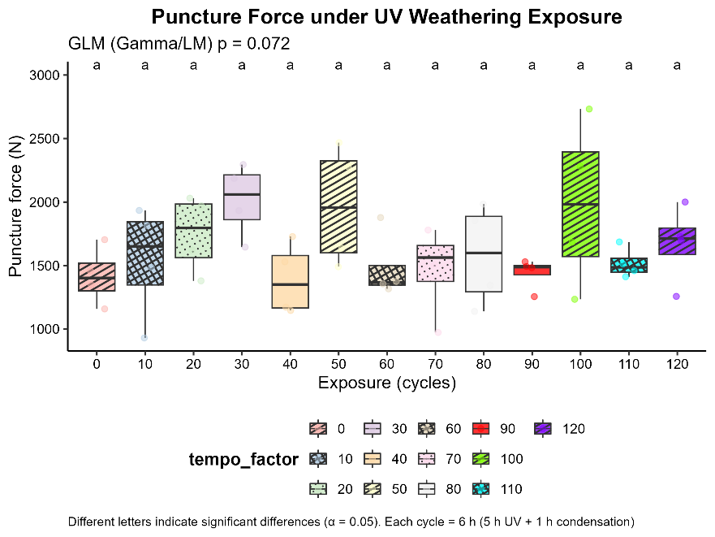
FIGURE 11 | Temporal evolution of maximum puncture force in Typha domingensis geocomposites under forced photochemical degradation, with identical letters indicating no statistically significant variation between exposure times.

The observed pattern, marked by initial stability, gradual increase, and subsequent stabilization without abrupt fluctuations, indicates a more robust mechanical response under multiaxial stress, less susceptible to degradation than uniaxial tensile loading [50, 51]. Similarly, the punch displacement showed no significant differences over time (GLM, Gamma–log link: LR χ²(10) = 9.2; p = 0.514), confirming that both strength and deformability under multiaxial loading are less sensitive to photochemical degradation than their uniaxial counterparts (Figure 12).
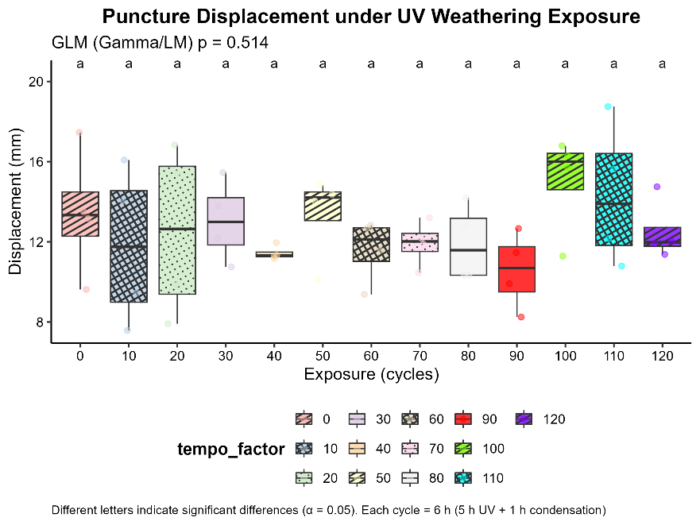
FIGURE 12 | Temporal evolution and distribution of punch displacement (mm) in Typha domingensis geocomposites under forced photochemical degradation, across the exposure period from 0 to 120 cycles.

The temporal analysis of puncture force between 0 and 110 days of exposure revealed a distinct pattern: an initial stable phase, followed by a gradual increase and subsequent stabilization, with no abrupt fluctuations. The modified exponential model yielded the best statistical fit (R² = 0.187; F(2,49) = 5.64; p = 0.006), representing a meaningful improvement in predictive capability over the models applied to tensile tests (R² = 0.108). This behavior suggests the occurrence of secondary resin curing and fiber microstructural reorganization, contributing to the early strength gain prior to stabilization. These findings reinforce the suitability of puncture testing for estimating the long-term mechanical performance of natural fiber composites subjected to controlled weathering [52, 53].
Bootstrap analysis confirmed this trend, indicating progressive growth in mean puncture strength: 1416.69 N in the control group (95% CI: 1189.14–1644.24 N), 1529.52 N at 10 days (95% CI: 1225.73–1833.31 N), and a peak of 2014.91 N at 30 days (95% CI: 1725.47–2304.35 N), followed by stabilization in the 1600–1700 N range. This behavior supports the hypothesis of a microstructural maturation effect, in which fiber rearrangement, compaction, and continued crosslinking of the resin matrix temporarily enhance mechanical strength before stabilization.
The coefficient of variation (CV) systematically decreased over time, reaching a minimum of 8.67% at 90 days, whereas tensile tests maintained higher dispersion (CV ranging from 14.2% to 36.6%). This difference reflects a more homogeneous stress field under punching shear. Bartlett’s test (K²= 12.43; df = 10; p = 0.258) confirmed the homogeneity of variances among exposure periods, validating the use of parametric models to describe temporal trends.
The observed mechanical performance can be attributed to anatomical characteristics of Typha domingensis fibers, which possess thin cell walls and a high content of cellulose (45–52%) and hemicellulose (23–28%). These features promote the formation of stable cross-links between hydroxyl and carbonyl groups of the applied resin [54]. The behavior after 60 cycles suggests a dynamic balance between surface oxidative degradation and resin protection, where oxidation is offset by the matrix’s diffusive barrier, resulting in stabilization of mechanical performance.

3.5 | Comparison Between Puncture and Tensile Tests

A direct comparison between the tests highlights fundamental structural and statistical differences. The average puncture force (1627.42 N) demonstrates the greater efficiency of multiaxial loading in mobilizing the three-dimensional fibrous architecture. This superiority is not merely geometric but reflects distinct internal mechanisms of energy dissipation and failure.
The reduction in the coefficient of variation under puncture shear (8.7%) compared to tensile tests (14–36%) confirms a more homogeneous stress field in multiaxial regimes, resulting in enhanced structural reliability for long-term applications in soil bioengineering. The Weibull shape parameter for puncture (β = 4.462) indicates predictable failure behavior, whereas for tensile tests (β = 3.403) it reveals a mixed regime in which both adhesive (fiber–matrix interface) and cohesive (within the fiber) failures coexist. In tensile testing, microcracks typically nucleate at discontinuities and propagate rapidly, causing localized rupture and reduced reliability [55]. In contrast, puncture loading distributes stress more evenly across the composite, enabling more fibers to contribute to the load-bearing response and reducing the probability of premature failure [40, 56, 57].
Temporal variability also differed markedly between test types. While tensile strength exhibited non-monotonic behavior, including a marked decline between 60 and 90 days followed by partial recovery, puncture strength followed a stable trajectory with no signs of accelerated degradation [58, 59]. These results confirm that resin-treated geocomposites are more reliable under multiaxial loading, which is a condition that more accurately reflects real-world field applications [60, 61]. The use of the conservative puncture percentile P₁₀ (1077.54 N) as a design lower bound offers a higher safety margin and enables the reduction of oversized safety factors without compromising structural integrity [62]. This approach makes the puncture criterion particularly suitable for field applications subject to distributed and anisotropic stresses, such as slope stabilization, erosion control layers, and reinforcement of cohesive soils.
The stabilization observed after 60 exposure cycles suggests a critical period of microstructural reorganization, during which internal stress redistribution, fiber densification, and consolidation of resin–fiber bonding predominate. Therefore, field monitoring efforts can be concentrated within this critical interval (30–60 cycles), allowing reduced inspection frequency thereafter and optimized resource allocation. This evidence-based approach enables planned interventions during the highest vulnerability phases, maximizing monitoring efficiency and improving risk management in bioengineering projects.
A comprehensive understanding of degradation mechanisms and the temporal evolution of strength and deformability in natural fiber composites directly supports the development of predictive service-life models. By integrating reliability parameters (β and η) with the temporal profiles of mechanical properties, it becomes possible to design safer, more adaptive systems that account for both the intrinsic variability of lignocellulosic materials and the cumulative effects of environmental exposure. This probabilistic–temporal approach expands the applicability of geocomposites under diverse operating conditions, ensuring structural performance aligned with long-term durability requirements. Progressive optimization of fiber surface treatments, based on reliability parameters from this study, represents a promising strategy to improve natural geocomposites with enhanced microstructural stability, photodegradation resistance, and functional durability [27, 63]. The application of such materials into soil conservation systems, erosion control structures, and green infrastructure tends to favor more sustainable engineering solutions, with reduced carbon footprints and lower maintenance costs [64]. The results presented herein support the advancement of nature-based solutions and affirm the technical and economic viability of using treated plant fibers as structural reinforcements in bioengineering projects and degraded soil recovery [65].

4 | Conclusion

Geocomposites reinforced with Typha domingensis fibers and treated with polymeric resin demonstrated stable mechanical behavior and high structural reliability under controlled environmental exposure, reinforcing their potential for use in soil bioengineering applications.
Weibull reliability analysis indicated that both tensile and puncture responses follow increasing hazard rate distributions (β > 1), consistent with progressive degradation mechanisms typical of lignocellulosic composites. While tensile loading exhibited moderate variability and characteristic life values compatible with field operational conditions, the puncture test yielded higher β values and lower dispersion, demonstrating its greater predictive capacity and structural stability.
The divergence in β values between loading regimes illustrates the superior ability of multiaxial loading to mobilize the composite’s three-dimensional fiber network. This leads to reduced stress concentrations and promotes a more uniform collective response. Time-series analysis further reinforced this pattern: tensile strength showed no statistically significant variation over time, while strain at break degraded significantly, confirming ductility as the most photochemically sensitive property. Meanwhile, Young’s modulus remained stable throughout the exposure, indicating preservation of elastic stiffness and integrity at the fiber–matrix interface even under extended UV exposure.
A comparison between uniaxial and multiaxial loading regimes revealed a transition from mixed adhesive–cohesive failure modes in tensile tests to predominantly cohesive failure under puncture shear. This indicates a more homogeneous stress distribution and efficient fiber mobilization under multiaxial stress, which better reflects real field loading conditions. Consequently, puncture testing is more suitable for defining design parameters in bioengineering projects.
The mechanical performance observed supports the use of resin-treated Typha domingensis geocomposites in medium- and long-term applications, particularly for erosion control, slope stabilization, and surface protection under predominantly multiaxial stress conditions. The application of conservative percentile values (P₁₀) derived from Weibull modeling enables designs with optimized safety factors, avoiding unnecessary oversizing without compromising reliability.
The results confirm that natural geocomposites from Typha domingensis treated with resin constitute a technically viable and environmentally sustainable alternative for geotechnical applications, combining structural reliability, temporal stability, and potential for integration into nature-based solutions.
Collectively, the results confirm that Typha domingensis-based natural geocomposites treated with resin represent a technically viable and environmentally sustainable alternative for geotechnical applications, combining structural reliability, temporal stability, and potential for integration into nature-based solution solutions.
Future research should expand the experimental design by including untreated controls and synthetic reference composites to isolate the protective effect of the resin and quantify relative performance improvements compared to conventional materials. The integration of nonlinear degradation modeling, extended exposure cycles, and simulations under variable environmental conditions (e.g., thermal and hygroscopic stresses) will allow identification of critical performance thresholds and support the development of more accurate predictive mechanistic models.

Conflicts of Interest

The authors declare no conflicts of interest.

Data Availability Statement

The study includes all the data that support the findings and conclusions, which can be found within the article and supplementary data file.

References
1. Pazhanivelan S, Lad SU, Selvakumar S, et al. Assessment of climate change on soil erosion using geospatial techniques: a review. Int J Environ Clim Change. 2025;15(6):191-209. doi:10.9734/ijecc/2025/v15i64883
2. Sanjay MR, Siengchin S, Ramu P, et al. Environmental ageing of plant-fibre reinforced polymer composites: A review. Polym Eng Sci. 2019;59(10):2115–2126. doi:10.1002/pen.25229
3. Koerner R. Geotextiles: From Design to Applications. Woodhead Publishing; 2016.
4. Karimah A, Ridho MR, Munawar SS, et al. A review on natural fibers for development of eco-friendly bio-composite: characteristics, and utilizations. J Mater Res Technol. 2021;13:2442-2458. doi:10.1016/j.jmrt.2021.06.014
5. Sathishkumar GK, Ibrahim M, Mohamed Akheel M, et al. Synthesis and mechanical properties of natural fiber reinforced epoxy/polyester/polypropylene composites: a review. J Nat Fibers. 2022;19(10):3718-3741. doi:10.1080/15440478.2020.1848723

6. Ingrassia LP, Virgili A, Canestrari F. Effect of geocomposite reinforcement on the performance of thin asphalt pavements: accelerated pavement testing and laboratory analysis. Case Stud Constr Mater. 2020;12:e00342. doi:10.1016/j.cscm.2020.e00342
7. Akter N, Das SC, Grammatikos SA, Saha J, Khan MA. Development of sustainable jute geotextiles by bitumen emulsion and polyester resin: effect of gamma radiation. J Eng Fibers Fabr. 2020;15:1558925020957969. doi:10.1177/1558925020957969
8. Amiandamhen SO, Meincken M, Tyhoda L. Natural fibre modification and its influence on fibre-matrix interfacial properties in biocomposite materials. Fibers Polym. 2020;21(4):677-689. doi:10.1007/s12221-020-9362-5
9. Gurunathan T, Mohanty S, Nayak SK. A review of the recent developments in biocomposites based on natural fibres and their application perspectives. Compos Part A Appl Sci Manuf. 2015;77:1–25. doi:10.1016/j.compositesa.2015.06.007
10. Reinhardt N, Breitsameter JM, Drechsler K, Rieger B. Fully bio‐based epoxy thermoset based on epoxidized linseed oil and tannic acid. Macromol Mater Eng. 2022;307(12):2200455. doi:10.1002/mame.202200455
11. Chunyuk DY, Selviyan SM. Experience in applying the Geocomposite method on soft soils in Moscow. E3S Web Conf. 2023;457:02045. doi:10.1051/e3sconf/202345702045
12. Marczak D, Lejcuś K, Grzybowska-Pietras J, et al. Biodegradation of sustainable nonwovens used in water absorbing geocomposites supporting plants vegetation. Sustain Mater Technol. 2020;26:e00235. doi:10.1016/j.susmat.2020.e00235
13. Grace JB. Effects of water depth on Typha latifolia and Typha domingensis. Am J Bot. 1989;76(5):762-768. doi:10.1002/j.1537-2197.1989.tb11371.x
14. Holanda FSR, Santos LDV, Melo JCR, et al. Influence of sodium hydroxide treatment on Typha domingensis fibers for geotextile manufacturing. ACS Omega. 2024;9(52):51040-51051. doi:10.1021/acsomega.4c05602
15. Manning SD, Pierce LR. Geotextile-based structure for vegetative growth enhancement and erosion resistance. Patent CA2996193C. World Intellectual Property Organization; 2018.
16. Tanasă F, Nechifor M, Ignat ME, Teacă CA. Geotextiles—a versatile tool for environmental sensitive applications in geotechnical engineering. Textiles. 2022;2(2):189-208. doi:10.3390/textiles2020011
17. Silveira MV, Casagrande MDT. Effects of degradation of vegetal fibers on the mechanical behavior of reinforced sand. Geotech Geol Eng. 2021;39(5):3875-3887. doi:10.1007/s10706-021-01733-y
18. Atoui S, Belaadi A, Boumaaza M, Alshaikh IMH, Ghernaout D. Weibull statistics and ANOVA analysis of the tensile mechanical characteristics of Chamaerops humilis cellulose fibers and sustainable twisted yarns. J Nat Fibers. 2024;21(1):2431677. doi:10.1080/15440478.2024.2431677
19. Sanjay MR, Siengchin S, Ramu P, et al. Environmental ageing of plant-fibre reinforced polymer composites: A review. Polym Eng Sci. 2019;59(10):2115–2126. doi:10.1002/pen.25229
20. Amroune S, Bezazi A, Dufresne A, et al. Comparative study of mechanical properties of polypropylene, polyethylene and polylactic acid fibers reinforced cement composites. Polym Eng Sci. 2015;55(9):2170–2181. doi:10.1002/pen.24092
21. Li X, Wang F. Effect of the statistical nature of fiber strength on the predictability of tensile properties of polymer composites reinforced with bamboo fibers: comparison of linear- and power-law Weibull models. Polymers. 2016;8(1):24. doi:10.3390/polym8010024
22. Staroverov O, Mugatarov A, Yankin A, Wildemann V. Description of fatigue sensitivity curves and transition to critical states of polymer composites by cumulative distribution functions. Frattura Integr Strutt. 2023;17(63):91-99. doi:10.3221/IGF-ESIS.63.09
23. Abbass A, Paiva MC, Oliveira DV, Lourenço PB, Fangueiro R. Insight into the effects of solvent treatment of natural fibers prior to structural composite casting: chemical, physical and mechanical evaluation. Fibers. 2021;9(9):54. doi:10.3390/fib9090054

24. Kumar R, Mikkelsen LP, Lilholt H, Madsen B. Weibull parameters determined from a comprehensive dataset of tensile testing of single carbon fibres. Data Brief. 2024;55:110717. doi:10.1016/j.dib.2024.110717
25. Alves Fidelis ME, Pereira TVC, Gomes OFM, de Andrade Silva F, Toledo Filho RD. The effect of fiber morphology on the tensile strength of natural fibers. J Mater Res Technol. 2013;2(2):149-157. doi:10.1016/j.jmrt.2013.02.003
26. Tsegaye M, Nazerian G, El Kadi M, et al. Improving degradation resistance of ensete ventricosum fibre in cement-based composites through fibre surface modification. Cem Concr Compos. 2024;146:105398. doi:10.1016/j.cemconcomp.2023.105398
27. Harle SM. Durability and long-term performance of fiber reinforced polymer (FRP) composites: a review. Structures. 2024;60:105881. doi:10.1016/j.istruc.2024.105881
28. Holanda FSR, de Castro JDS, Santos LDV, et al. Degradation of geotextiles of Typha latifolia Linn used in soil bioengineering techniques. Ciênc Florest. 2020;30(4):1147-1160. doi:10.5902/1980509842416
29. Pramudia M, Umami MK, Prasetyo T, Roziqin F. The influence of sodium hydroxide (NaOH) solution concentration on tensile strength of corn husk fiber-epoxy resin composite. J Phys Conf Ser. 2024;2972(1):012050. doi:10.1088/1742-6596/2972/1/012050
30. Oğuz ZA. Investigation of UV aging influence on low velocity impact behavior of interply hybrid composites. Int Adv Res Eng J. 2025;9(1):35-42. doi:10.35860/iarej.1570089
31. Thapliyal D, Verma S, Sen P, et al. Natural fibers composites: origin, importance, consumption pattern, and challenges. J Compos Sci. 2023;7(12):506. doi:10.3390/jcs7120506
32. Seoane-Rivero R, Ares-Elejoste P, Gondra K, et al. Sustainable epoxy composites with UV resistance based on new kraft lignin coatings. Molecules. 2024;29(15):3697. doi:10.3390/molecules29153697
33. Krauklis AE, Karl CW, Rocha IBCM, et al. Modelling of environmental ageing of polymers and polymer composites—modular and multiscale methods. Polymers. 2022;14(1):216. doi:10.3390/polym14010216
34. Carneiro JR, Lopes ML. Natural weathering of polypropylene geotextiles treated with different chemical stabilisers. Geosynth Int. 2017;24(6):544-553. doi:10.1680/jgein.17.00020
35. Abdelmohsen AM, Obada DO, Zakikhani P, et al. Mechanical Performance Enhancement in Natural Fibre-Reinforced Thermoplastic Composites Through Surface Treatment and Matrix Functionalisation. Polym Eng Sci. 2025;65(2):412–428. doi:10.1002/pen.26847
36. Vargas J, Jalalvand M, Meza JM. Improving interfacial shear strength of fique fibres using an acrylic coating. Sci Prog. 2023;106(4):00368504231207199. doi:10.1177/00368504231207199
37. Kaya C, Stegmaier T, Gresser GT. Investigation of the protective function of a lignin coating of natural fiber geotextiles against biodegradation. Materials. 2023;16(13):4849. doi:10.3390/ma16134849
38. Lalaymia I, Belaadi A, Boumaaza M, et al. Weibull statistic and artificial neural network analysis of the mechanical performances of fibers from the flower Agave plant for eco-friendly green composites. J Nat Fibers. 2024;21(1):2305228. doi:10.1080/15440478.2024.2305228
39. Richter H, Thümmler S, Müller K, et al. Complex degradation behavior in fiber-reinforced composites: Requirements for predictive models. Polym Eng Sci. 2023;63(6):1892–1908. doi:10.1002/pen.26354
40. Eleutério T, Trota MJ, Meirelles MG, Vasconcelos HC. A review of natural fibers: classification, composition, extraction, treatments, and applications. Fibers. 2025;13(9):119. doi:10.3390/fib13090119
41. Holanda FSR, Santos LDV, de Melo JCR, et al. Resistance of the fiber-derived geotextile from Typha domingensis submitted to field degradation. Sci Rep. 2024;14(1):8648. doi:10.1038/s41598-024-56978-3
42. Chen W, Xiao CJ, Xu ZJ, et al. New water-based anti-corrosion chemical materials in engineering repairing. Adv Mater Res. 2011;287-290:249-252. doi:10.4028/www.scientific.net/AMR.287-290.249
43. Bone JE, Sims GD, Maxwell AS, et al. On the relationship between moisture uptake and mechanical property changes in a carbon fibre/epoxy composite. J Compos Mater. 2022;56(14):2189-2199. doi:10.1177/00219983221091465
44. Holanda FSR, Santos LDV, Sussuchi EM, et al. Resistance of Syagrus coronata fibers in waterproof-coated natural geotextiles under environmental degradation. Front Sustain. 2025;6:1552255. doi:10.3389/frsus.2025.1552255

45. Baley C, Gomina M, Breard J, Bourmaud A, Davies P. Variability of mechanical properties of flax fibres for composite reinforcement: a review. Ind Crops Prod. 2020;145:111984. doi:10.1016/j.indcrop.2019.111984
46. Khan F, Ahmad Z, Khosa SK, et al. A new modification of the flexible Weibull distribution based on power transformation: Monte Carlo simulation and applications. Heliyon. 2023;9(6):e17238. doi:10.1016/j.heliyon.2023.e17238
47. Guan T, Liu Y, Li Y, et al. Mechanical behavior and failure analysis of 2D-C/SiC composite under on- and off-axis loading. Compos Struct. 2025;371:119518. doi:10.1016/j.compstruct.2025.119518
48. Thakur VK, Thakur MK, Gupta RK. Review: raw natural fiber–based polymer composites. Int J Polym Anal Charact. 2014;19(3):256-271. doi:10.1080/1023666X.2014.880016
49. Infante DJU, Martinez GMA, Arrua PA, Eberhardt M. Shear strength behavior of different geosynthetic reinforced soil structure from direct shear test. Int J Geosynth Ground Eng. 2016;2(2):17. doi:10.1007/s40891-016-0058-2
50. Petinakis E, Yu L, Simon GP, et al. Interfacial adhesion in natural fiber‐reinforced polymer composites. In: Lignocellulosic Polymer Composites. Wiley; 2014:17-39. doi:10.1002/9781118773949.ch2
51. Thakur JK, Han J, Pokharel SK, Parsons RL. Performance of geocell-reinforced recycled asphalt pavement (RAP) bases over weak subgrade under cyclic plate loading. Geotext Geomembr. 2012;35:14-24. doi:10.1016/j.geotexmem.2012.06.004
52. Zając J, Bogucki R, Stępiński Z, et al. Additively manufactured polymeric composites with healing capability: A review. Polym Eng Sci. 2023;63(5):1556–1570. doi:10.1002/pen.25921
53. Bazan P, Gajda M, Nosal P, et al. Influence of copper oxide particle size on the properties of epoxy resin. Appl Sci. 2024;14(6):2534. doi:10.3390/app14062534
54. Palanisamy S, Ramakrishnan SK, Santulli C, Khan T, Ahmed OS. Mechanical and wear performance evaluation of natural fiber/epoxy matrix composites. BioResources. 2024;19(4):8459-8478. doi:10.15376/biores.19.4.8459-8478
55. Belnoue JPH, Hallett SR. Cohesive/adhesive failure interaction in ductile adhesive joints. Part I: a smeared-crack model for cohesive failure. Int J Adhes Adhes. 2016;68:359-368. doi:10.1016/j.ijadhadh.2016.03.009
56. Gurunathan T, Mohanty S, Nayak SK. A review of the recent developments in biocomposites based on natural fibres and their application perspectives. Compos Part A Appl Sci Manuf. 2015;77:1-25. doi:10.1016/j.compositesa.2015.06.007
57. Abo-Alazm EAE, Abdou A, Hassouneh L, Safy RK. Reliability of an innovative slab shear versus microtensile bond strength test: mechanical and finite element analysis. Eur J Dent. 2024;18(01):182-195. doi:10.1055/s-0043-1763498
58. Pot GJ, Van Overschelde PA, Keulemans F, Kleverlaan CJ, Tribst JPM. Mechanical properties of additive-manufactured composite-based resins for permanent indirect restorations: a scoping review. Materials. 2024;17(16):3951. doi:10.3390/ma17163951
59. Sagala PV, Vemuri S, Guptha AB, et al. Compressive strength evaluation of two composites with and without fiber reinforcement used as restorative material in incisal edge: an in-vitro study. J Clin Exp Dent. 2025;17:e168-e173. doi:10.4317/jced.62410
60. Růžek V, Dostayeva AM, Walter J, Grab T, Korniejenko K. Carbon fiber-reinforced geopolymer composites: a review. Fibers. 2023;11(2):17. doi:10.3390/fib11020017
61. Sambucci M, Sibai A, Valente M. Recent advances in geopolymer technology. A potential eco-friendly solution in the construction materials industry: a review. J Compos Sci. 2021;5(4):109. doi:10.3390/jcs5040109
62. Basu G, Roy AN, Sanyal P, et al. Bioengineering of river earth embankment using natural fibre-based composite-structured geotextiles. Geotext Geomembr. 2019;47(4):493-501. doi:10.1016/j.geotexmem.2019.03.002
63. Samanth M, Subrahmanya Bhat K. Conventional and unconventional chemical treatment methods of natural fibres for sustainable biocomposites. Sustain Chem Clim Action. 2024;3:100034. doi:10.1016/j.scca.2023.100034
64. Lazorenko G, Kasprzhitskii A, Yavna V, et al. Effect of pre-treatment of flax tows on mechanical properties and microstructure of natural fiber reinforced geopolymer composites. Environ Technol Innov. 2020;20:101105. doi:10.1016/j.eti.2020.101105
65. Khalid MY, Al Rashid A, Arif ZU, et al. Natural fiber reinforced composites: sustainable materials for emerging applications. Results Eng. 2021;11:100263. doi:10.1016/j.rineng.2021.100263

